**ME 111**

**Projection of Solids**

|  |  |  |
| --- | --- | --- |
| 1 | A cylinder 40 mm diameter and 50 mm axis is resting on one point of a base circle on VP while it’s axis makes 450 with VP and FV of the axis 350 with HP. Draw projections | 30 |
| 2 | A right circular cone, 40 mm base diameter and 60 mm long axis is resting on HP on one point of base circle such that it’s axis makes 450 inclination with HP and 400 inclination with VP. Draw it’s projections. | 35 |
| 3 | A square pyramid 30 mm base side and 50 mm long axis is resting on it’s apex on HP, such that it’s one slant edge is vertical and a triangular face through it is perpendicular to VP. Draw it’s projections. | 35 |

.

**Solution**

**1**

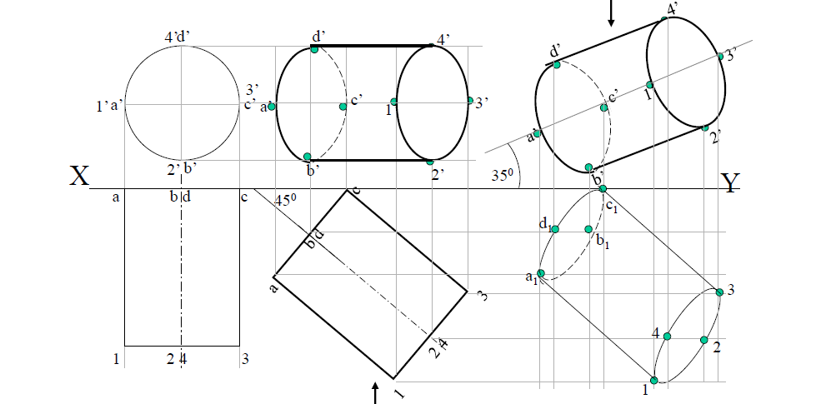

**2**

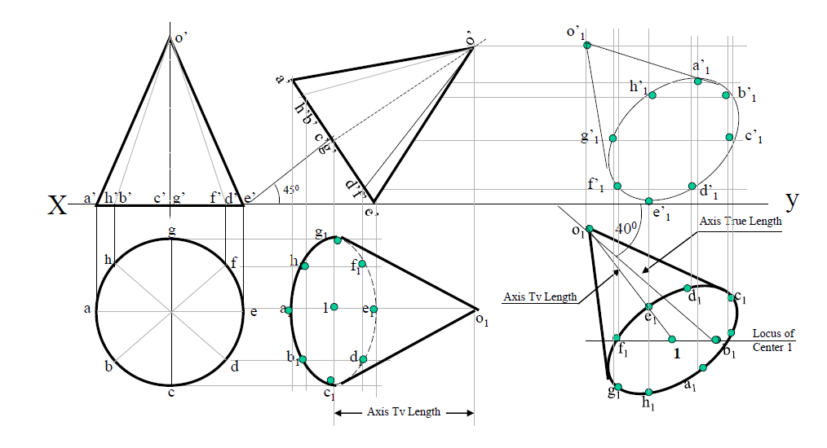

**3**

